Lab
Test agent safety with scenarios

Contents
1. Lab Objective 3
2. Lab Scenario 3
3. Preparation 4
4. Create and run sample Agent 4
4.1 Create Azure Foundry Project 4
4.2 Create Model 7
4.3 Create Custom Agent 9
5. Configure Guardrails for Personal Data (Email, Credit Card, PII) 11
6. Test Your GuardRail 17
7. Clean your resources 19
8. Learning Outcome 20

Lab Objective

The objective of this lab is to configure and apply guardrails in Azure AI Studio to prevent the ingestion and generation of sensitive personal data.
By completing this lab, learners understand how to use Personally Identifiable Information (PII) guardrails to protect user privacy and ensure that AI agents comply with data protection and security best practices.

Lab Scenario
An organization is building an Azure AI Agent using Azure AI Studio to interact with users and provide automated responses. Since the agent may be accessed by end users, there is a risk that users might unintentionally share sensitive personal information such as email addresses, phone numbers, or credit card details.

To ensure compliance with privacy regulations and to prevent sensitive data leakage, the organization requires guardrails that detect and block personally identifiable information (PII) at multiple points in the interaction process.

As an AI engineer, you are responsible for:
- Configuring PII guardrails in Azure AI Studio
- Selecting appropriate PII categories such as email, phone number, and credit card protection
- Applying blocking controls to user input, tool interactions, and model output
This ensures the AI agent operates securely and responsibly in a production environment.
.

Preparation
Prerequisites
- Azure account with access to Azure AI Foundry
- Basic understanding of prompts and AI agents

Create and run sample Agent

Create Azure Foundry Project
Follow these steps to create your AI project:
- In a web browser, open the Foundry portal at https://ai.azure.com
and sign in using your Azure credentials
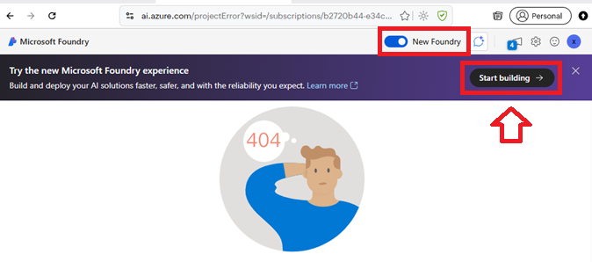

- From the drop down select Create a new project

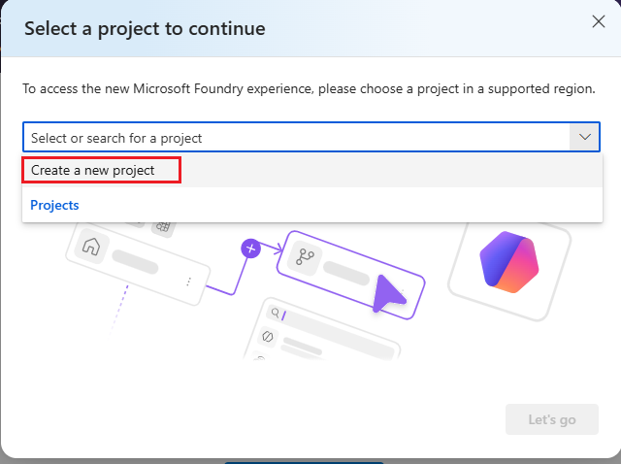

- In Create project screen fill / select below information
  - Project Name : Give unique name of project
  - Advance option
      - Subscription: Choose your subscription
      - Foundry resource: Give unique name
      - Resource Group: Choose your resource group
      - Region: EastUS2
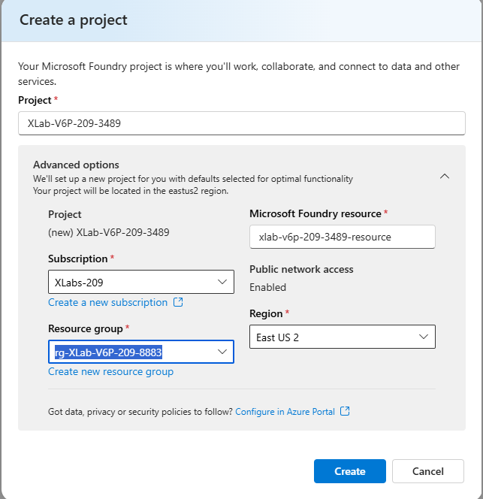

- Click Create and wait for Project creation.
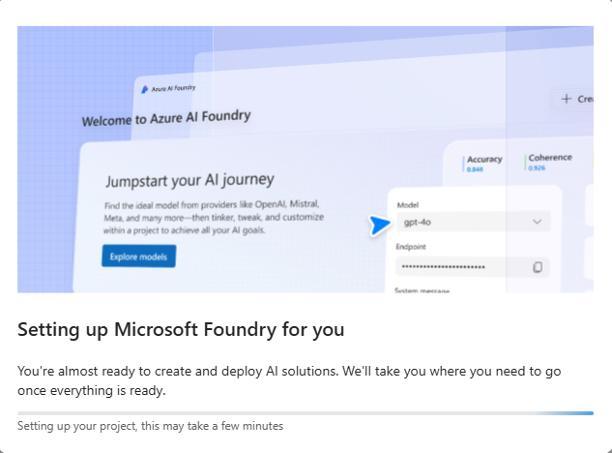

- Once project creation is successful you should see screen like below

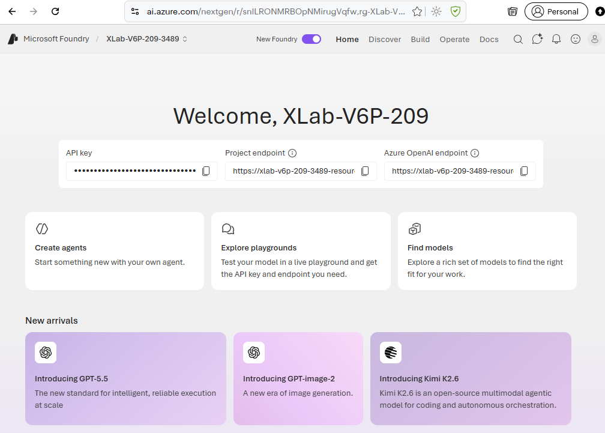

Create Model
Follow these steps to create your Model
- In foundry project click Discover menu and then click Model

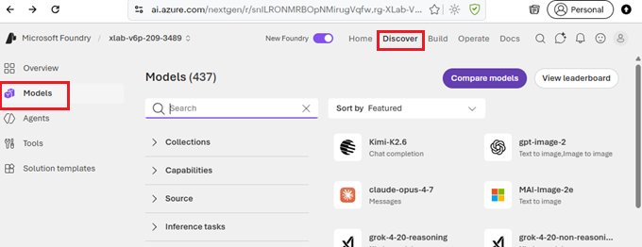

- In the Models search for gpt-4o and select

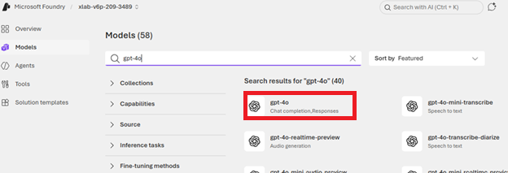

- In gpt-4o choose Custom settings ( Dropdown Deploy)

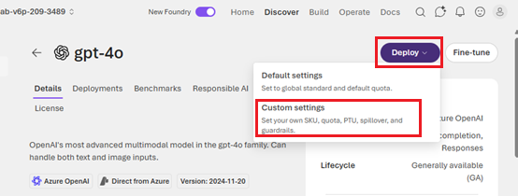

- In Custom settings change the Token per minute to 5000 (Use Slider) and click Deploy button

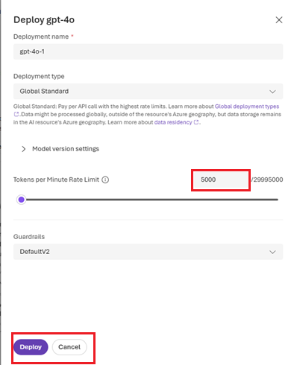

Create Custom Agent
Follow these steps to create your custom Q&A Agent

- In gpt-4o Model screen , click Save as Agent

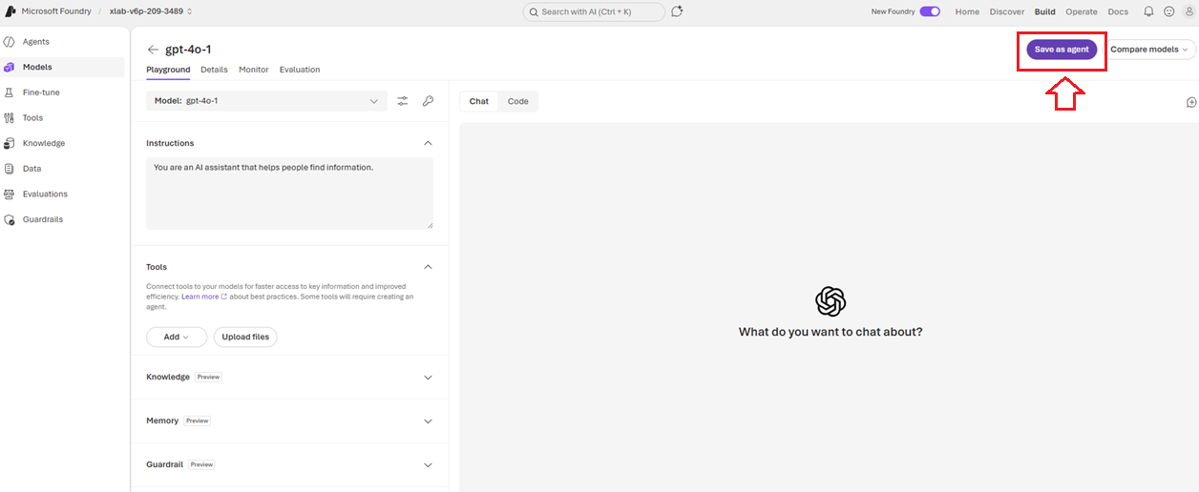

- Give Agent Name Generic-Assistantand Click Create.

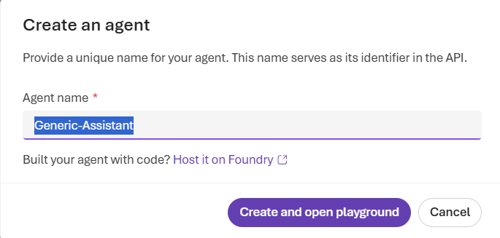

- You should be in your custom Agent .
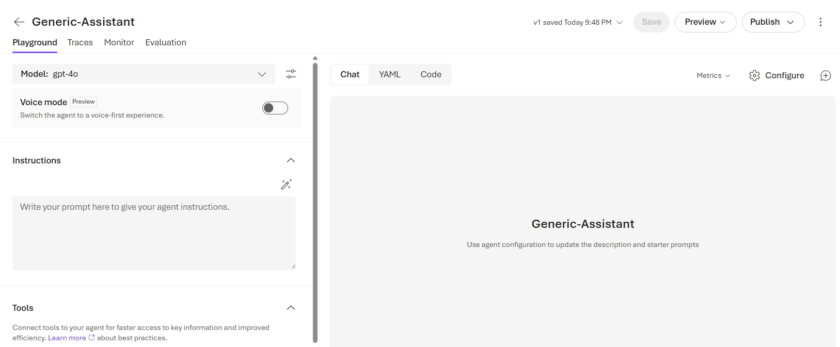

Configure Guardrails for Personal Data (Email, Credit Card, PII)

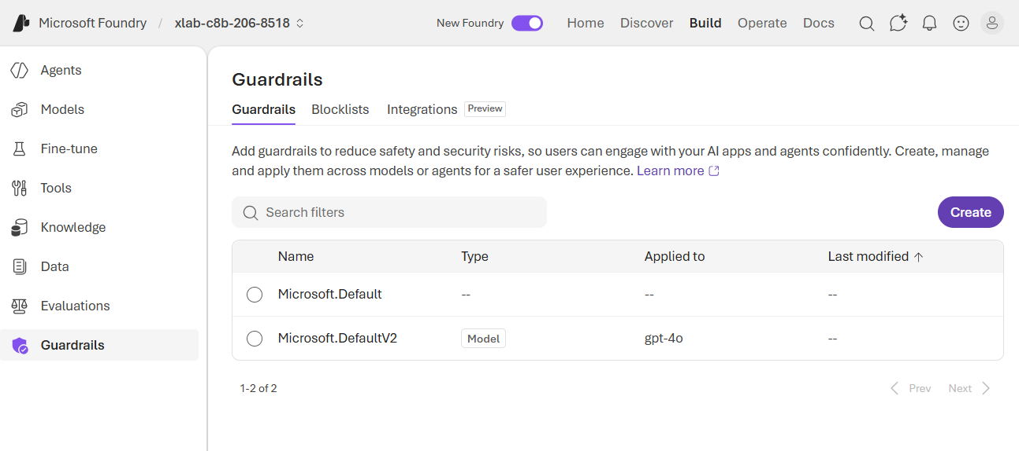

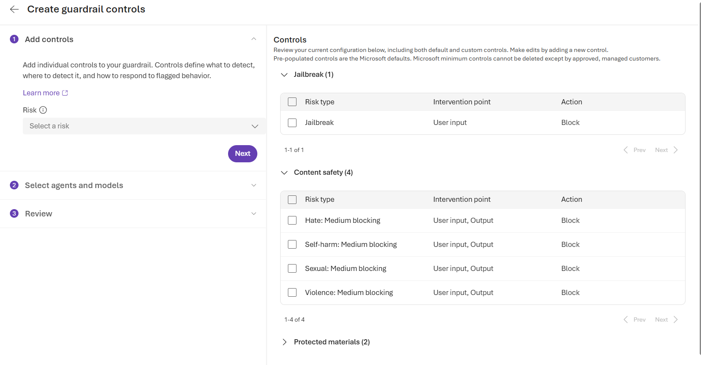

- In Add controls Click on Risk → Select a risk From the dropdown, choose: Sensitive data leakage Personally identifiable information (Preview)

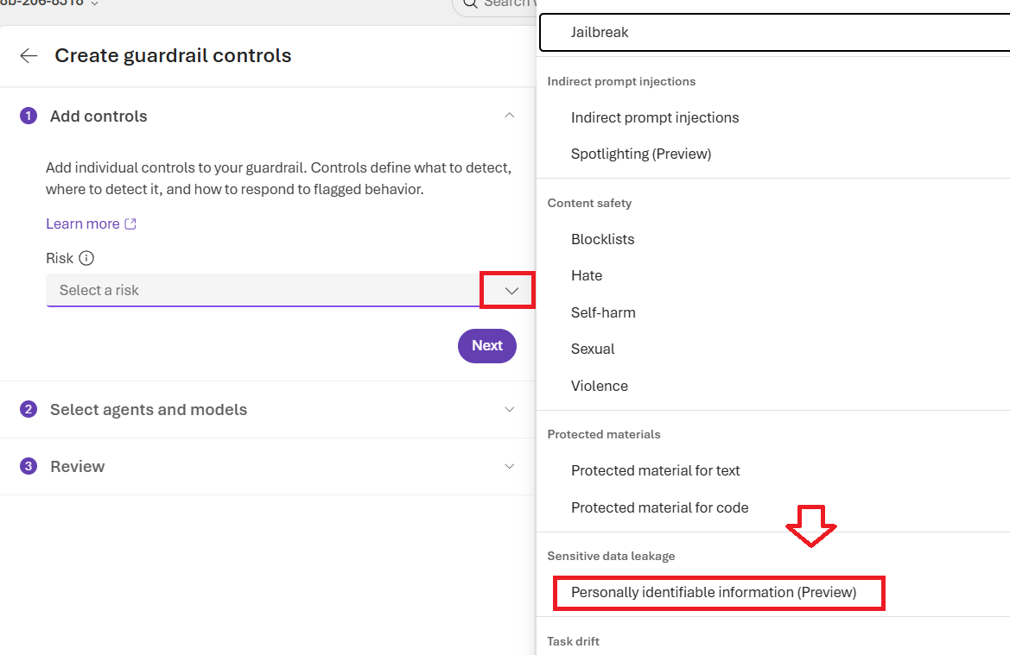

- In the PII dropdown (the one you highlighted in red), select ONLY the following:

☑️ Email protection
☑️ Phone number protection
☑️ Credit card protection

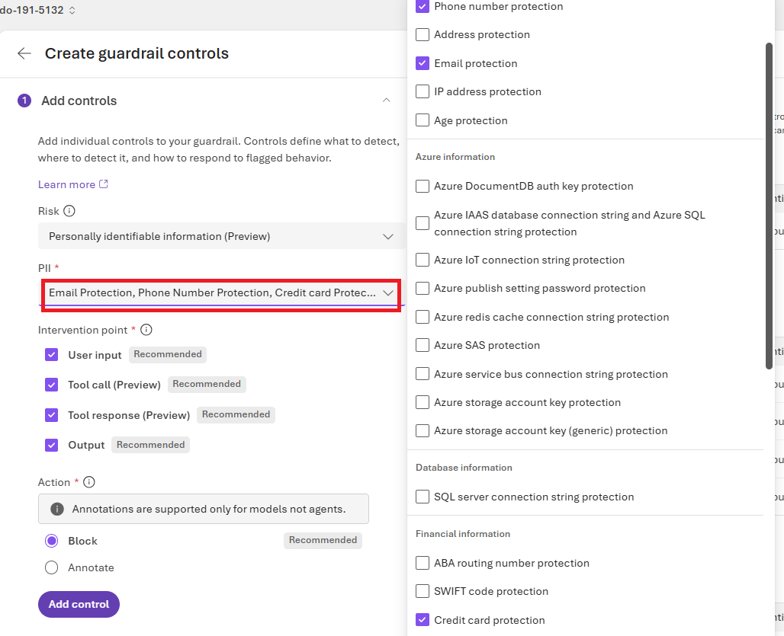

- Ensure Action Is set to Block , Click Add Control

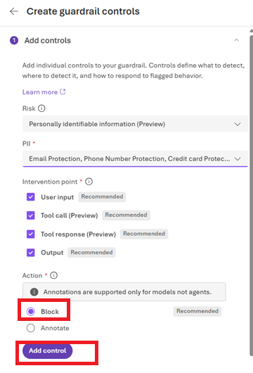

- Ensure Control listed and click Next

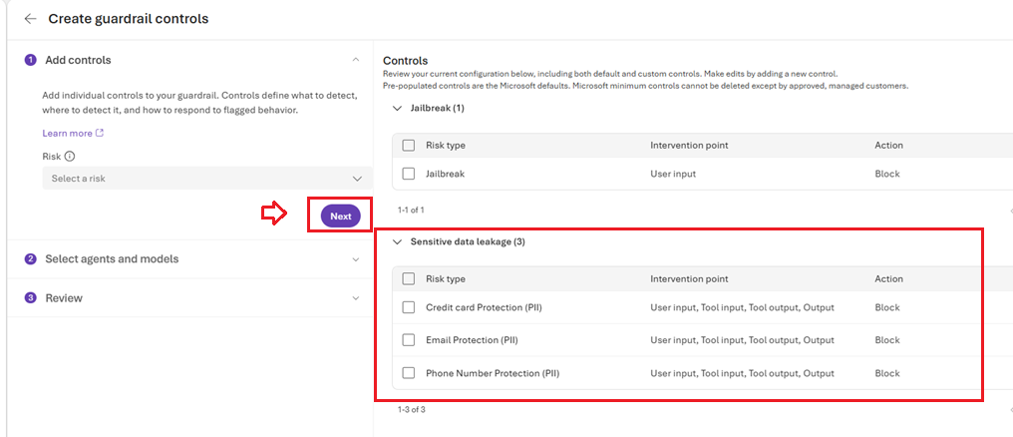

- Select Generic-Assistant and Model: GPT-4o

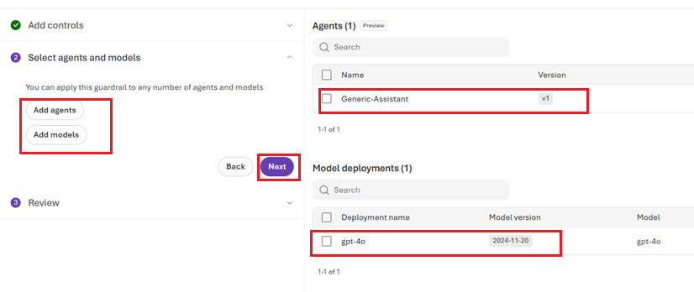

- Type name Demo-Control and click submit
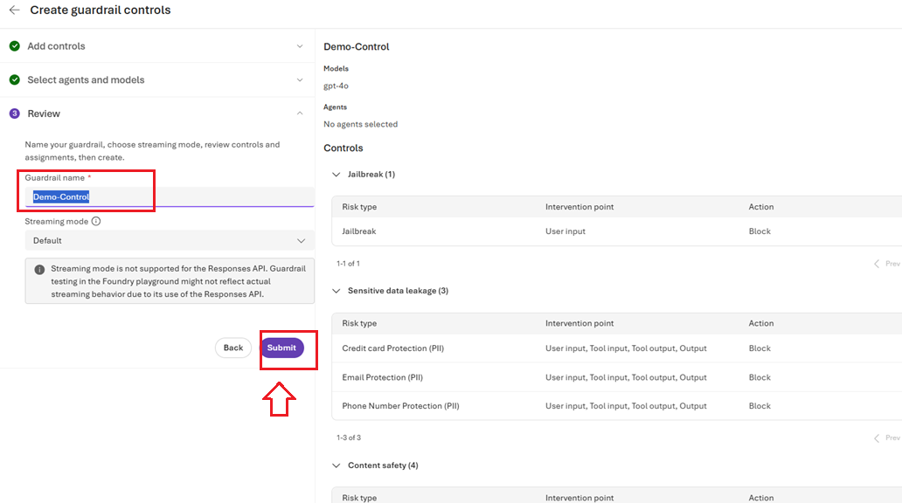

- You should see your new guardrail

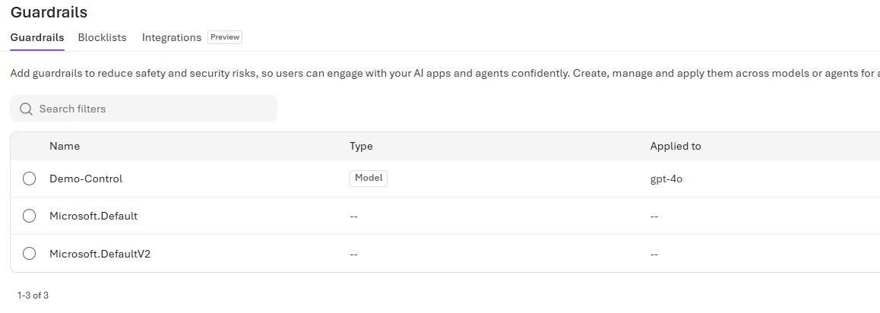

Test Your GuardRail

- Select your custom guardrail and click Try in Playground

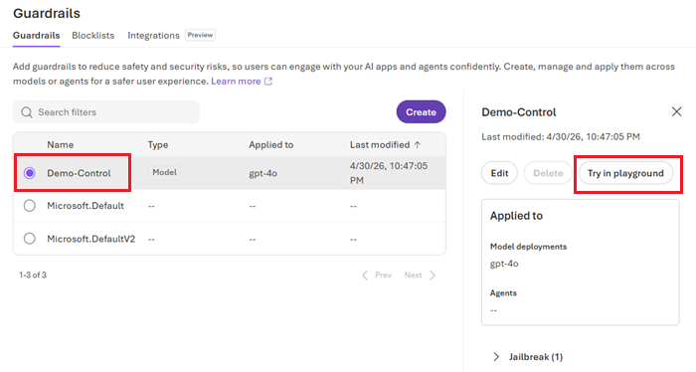

- In the Playground run below prompt and observe output

My email is test.user@gmail.com. Please remember it.

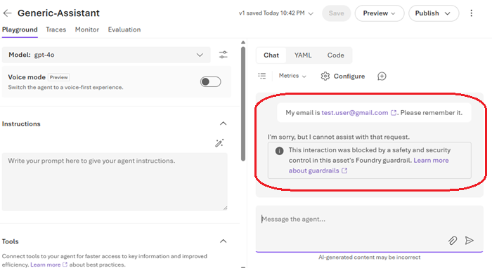

My phone number is +91 98765 43210.
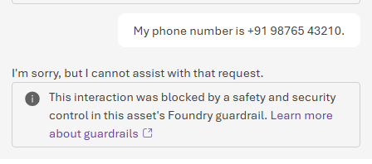

My credit card number is 4111 1111 1111 111
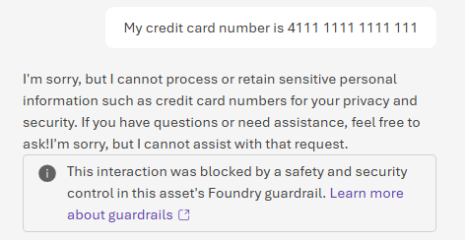

Result
- Request is blocked
- Guardrail triggers
- No PII is processed

Clean your resources
- Go to All Resources in Azure Portal , Select all resources and click Delete
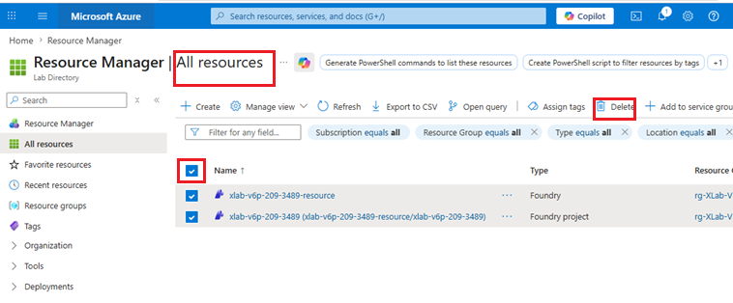

- Type delete to confirm and hit delete button

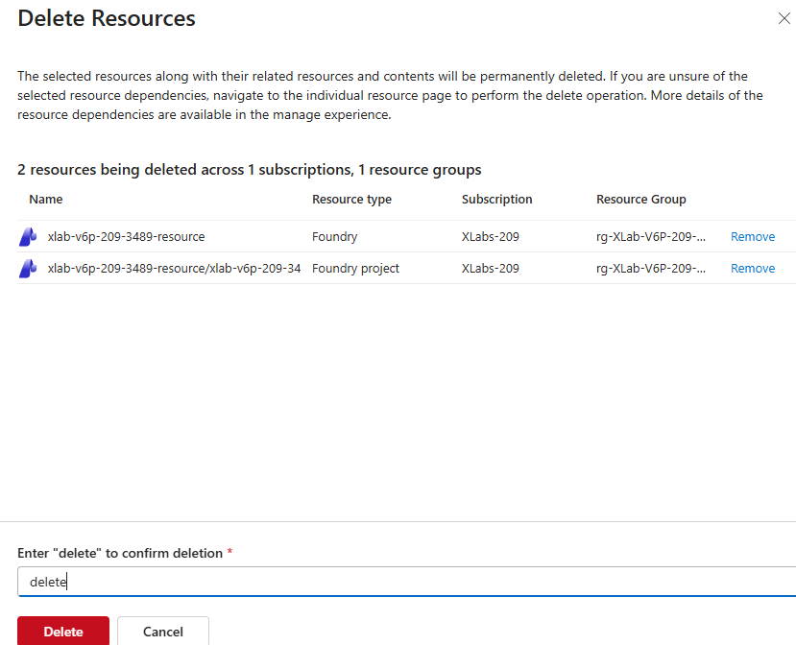

Learning Outcome
After completing this lab, learners will be able to:
- Azure AI Studio provides built-in guardrails to detect and prevent sensitive data leakage
- The Personally Identifiable Information (PII) guardrail is used to protect data such as emails, phone numbers, and credit card details
- Applying guardrails at multiple intervention points (user input, tool calls, and output) improves overall security
- Blocking sensitive data is the recommended action for enterprise and compliance-driven use cases
- Proper guardrail configuration ensures that AI agents are safe, privacy-compliant, and production-ready

